

**Course Title:** Fundamentals of Data Structure

**Course Code:** 24BTELY106

**QUESTION BANK**

**MODULE-1**

**2MARKS**

**1.Define Algorithm**

An algorithm can be defined as a step by step procedure that provides solution to a given problem. It comprises of a well-defined set of finite number of steps or rules that are executed sequentially to obtain the desired solution.

**2.What are Characteristics of an Algorithm**

* + - 1. An algorithm must comprise of a finite number of steps.
      2. It should have zero or more valid and clearly defined input values.
      3. It should be able to generate at least a single valid output based on a valid input.
      4. It must be definite, i.e., each instruction in the algorithm should be defined clearly.
      5. It should be correct, i.e., it should be able to perform the desired task of generating correct output from the given input.
      6. There should be no ambiguity regarding the order of execution of algorithm steps.
      7. It should be able to terminate on its own, i.e., it should not go into an infinite loop.

**3.Write an algorithm to interchange two numbers.**

Interchange (X, Y)

Step 1: Begin

Step 2: Set X = X + Y

Step 3: Set Y = X – Y

Step 4: Set X = X - Y

Step 5: Write (X, Y)

Step 6: End

4.Write an algorithm to calculate the average of 15 numbers.

Average (avg, sum)

Step 1: Begin

Step 2: Set avg = 0.0 and sum = 0

Step 3: for i = 1 to 15 do

Step 4: Read (a)

Step 5: sum = sum + a

Step 6: end-for

Step 7: avg = sum/15 Step 8: Write (avg)

Step 9: End

**5.Write an algorithm to sort n numbers**

Sort (a, n)

Step 1: Begin

Step 2: Read (n)

Step 3: for i = n to 2 do

Step 4: for j = 1 to i-1 do

Step 5: if a[j]> a[j+1] then

Step 6: Interchange a[j] and a[j+1]

Step 7: end-if

Step 8: end-for

Step 9: end-for

Step 10: End

6. **Write an algorithm to calculate the sum of two numbers**

Step 1: Start

Step 2: Read val1 and val2

Step 3: sum = val1 + val2

Step 4: Display sum

Step 5: Stop

**7.Write an algorithm to calculate the area of circle**

Step 1: Start

Step 2: Read radius

Step 3: area = π * radius * radius

Step 4: Display area.

Step 5: Stop

**8.Write an algorithm to determine whether a number is even or odd**

Step 1: Start

Step 2: Read val

Step 3: if val % 2 == 0; proceed to step 4, otherwise go to step 5.

Step 4: Display “Given number is even”, go to step 6.

Step 5: Display “Given number is odd”, go to step 6.

Step 6: Stop

**9.What is an asymptotic notation? Explain the various types of asymptotic notations. (or) list the asymptotic notations used in Algorithm analysis.**

Asymptotic notation is the most simple and easiest way of describing the running time of an algorithm. It represents the efficiency and performance of an algorithm in a systematic and meaningful manner. Asymptotic notations describe time complexity in terms of three common measures, best case (or ‘fastest possible’), worst case (or ‘slowest possible’), and average case (or ‘average time’).

The three most important asymptotic notations are:

1. Big-Oh notation
2. Omega notation
3. Theta notation

**10.What is algorithm complexity? (or)list & define the two metrics used to measure the performance of an algorithm.**

Algorithm complexity is a measure of how many resources are needed to complete a task or solve a problem. It's measured using time complexity and space complexity.

**Time complexity**

The amount of time it takes to complete each statement in an algorithm

**Space complexity**

The amount of memory used by an algorithm.

space required by an algorithm for its complete execution, for a given set of inputs.

**11.What is a data structure? What are its various characteristics?**

A data structure is **a way of organizing and storing data in a computer** so that it can be accessed and used efficiently.

Characteristics of Data Structure

* + - 1. It depicts the logical representation of data in computer memory.
      2. It represents the logical relationship between the various data elements.
      3. It helps in efficient manipulation of stored data elements.
      4. It allows the programs to process the data in an efficient manner.

**12.What are the different types of data structures?**

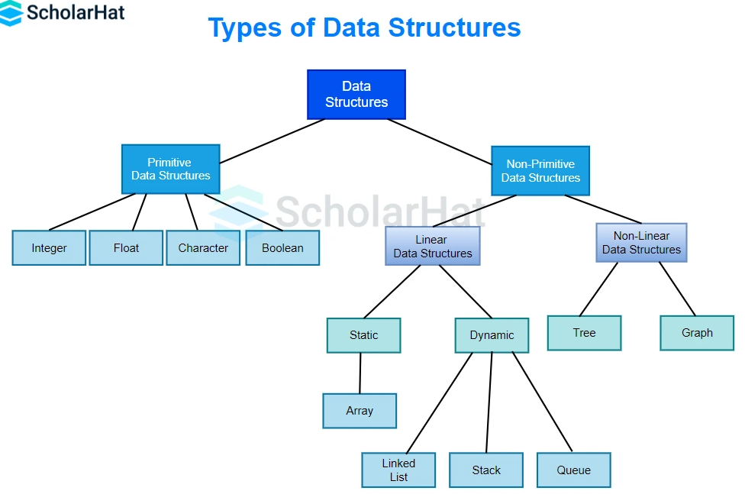

**13.List & Explain Primitive data structures**

int – used to store integer values

float – used to store decimal values

double – used to store decimal values of higher precision and range

char – used to store a single character

bool – stores Boolean values

**14.Define any two non-primitive data structures.**

**Stacks:**

stack is a linear data structure that maintains a list of elements in such a manner that elements can be inserted or deleted only from one end of the list. This end is referred as top of the stack.

**Queue:**

Queue is a linear data structure that maintains a list of elements in such a manner that elements are inserted from one end of the queue (called *rear*) and deleted from the other end (called *ƒront*). Queue is based on the First-In-First-Out (FIFO) principle, which means the element that is first added to the queue is also the one that is first removed from the queue**.**

**15.List the typical operations associated with derived data structure types.**

insertion, deletion, searching, traversal, sorting, accessing elements by index, updating element values, concatenation (for strings), and various operations specific to the data structure type like pushing/popping (stack), enqueuing/dequeuing (queue), or traversing nodes (tree).

**16 What is an Array? Explain the syntax of declaring 1 D Array.**

Array is defined as a collection of elements of the same type

Array Declaration

datatype arrayname[size];

**17.Consider the following two-dimensional arrays.**

**(i)A[3][7]**

**(ii)B[2][3]**

(i) 21 elements (i) 6 elements

**18. Explain the Ω (Omega) asymptotic notation.**

Consider f(n) and g(n) to be two positive functions of n, where n is the size of the input data. Then, f(n) is omega of g(n), if and only if there exists a positive constant C and an integer n0, such that f(n) ≥ Cg(n) and n > n0 Then we say f(n) 𝝐 𝜴(g(n))



**19.What is row major order & column major order?**

* Row major order It is the memory representation of a two-dimensional array in row-by-row fashion.
* Column major order It is the memory representation of a two-dimensional array in column- by-column fashion.

**Part B& Part C questions**

**1.What is an algorithm? List the characteristics of an algorithm.**

**2.Write a C program to perform linear search on an array.**

**3.Write a C program or an algorithm to perform Matrix Addition.**

**4.Write a C program or an algorithm to perform Matrix Subtraction.**

**5.Write a C program or an algorithm to perform Matrix Multiplication.**

**6.Write a C program or an algorithm to perform Matrix Transpose**

**7.Explain different types of data structures in detail.**

**8.Describe the insertion operation on one dimensional array with algorithm and a corresponding program.**

**9.Explain in detail about asymptotic notation?**

**10.Describe the Deletion operation on one dimensional array with algorithm and a corresponding program.**